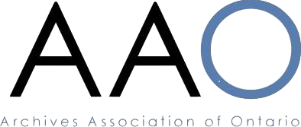

Archives Association of Ontario (AAO) Nomination Form 2023

Board of Directors

I wish to nominate the following person for the position of _____________________, who, as a member in good standing of the AAO, is eligible to serve on the Board of Directors of the AAO.
___________________________________________________________
(Name of Nominee)

The above person has indicated in writing their willingness to stand for election or to be presented at the Annual General Meeting (AGM) on May 12, 2023.
Nomination forms must be signed by at least three (3) nominators who are voting members of the AAO.
Printed Names and Signatures of Nominators:
____________________________________________
____________________________________________
____________________________________________
Please have completed forms sent by e-mail, under the subject line, “Nominations 2023”, to the attention of the Nominations Committee via the AAO Office at aao@aao-archivists.ca, on or before close of business on Monday, April 3, 2023, for consideration at the Annual General Meeting (AGM).
Under the AAO Constitution, nominations can also be received from the floor on the day of the AGM, provided that the nominations are in writing and are signed by at least three (3) voting members, and further provided that said nominees indicate their acceptance of such nominations in writing or in person at the time of the nomination.

